

MOLD TOWN COUNCIL
BEREAVEMENT SERVICES

CEMETERY REGULATIONS

April 2025

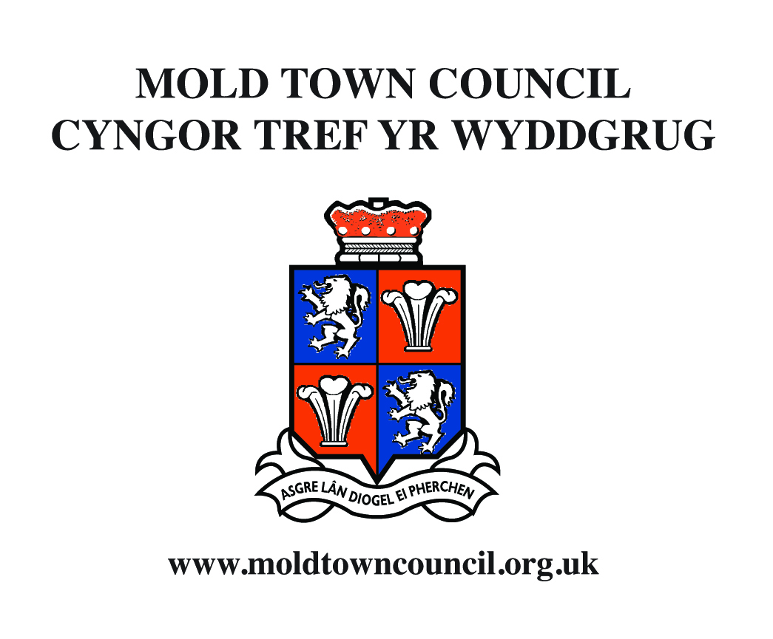

Dear Sir or Madam,

On behalf of Mold Town Council, I wish to offer you our condolences on your recent bereavement and understand that you wish for the burial to take place at Mold Cemetery.

The Town Council owns and manages the Cemetery and takes great pride in its appearance.

In order to maintain the Cemetery to a standard befitting a place of remembrance, the Town Council has established these Cemetery Regulations. They are intended to help those who have purchased plots and their relatives, understand the arrangements within the cemetery itself and the type of memorials allowed.

I appreciate that this is a difficult time for you but ask that you do have a look at the Regulations. If there are any queries please contact either the Cemetery Superintendent (01352 753820) or myself (01352 751819). Alternatively, you can discuss any concerns with your Funeral Director who will, I am sure, help wherever possible and contact us if necessary.

Thank you for your time.

Yours faithfully,

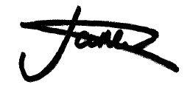

Jo Lane
Town Clerk and Finance Officer
MOLD TOWN CEMETERY

REGULATIONS

Mold Town Council and the Cemetery Superintendent take great pride in the appearance of the Cemetery and every effort is made to maintain the grounds to a standard befitting a place of remembrance and tribute.

In order to facilitate a high standard of maintenance, these regulations will be strictly enforced by the Council.

The Cemetery Committee of the Town Council reserves the right at any time to make any alterations to these regulations which may be deemed necessary.

1. CEMETERY LAYOUT

The lower cemeteries shall be laid out in a lawned system whereby only a single headstone (with or without integral tribute holder) shall be permitted at the head of the grave. The headstone shall stand upon a rectangular concrete base measuring 3 feet (0.91 metres) by 2 feet (610mm) by 2 inches (50mm).

The placing of floral tributes, shrubs, flower vases and other containers shall be restricted to the shelf of the headstone or the concrete base where this exists or within a space of 20 inches from the headstone face other than during a two-week period immediately following an interment. Please see page 9 for a diagram.

The planting of flowers, shrubs, other vegetation or placing of all other memorial tributes, such as solar lights and ornaments, is not permitted, as during inclement weather they can blow away, or could be damaged during maintenance of the grounds. No area of grave space will be permitted to be enclosed or covered by curbstones, plinth stones, palisades, rails, chains or in any other manner. The laying of stone chippings or similar material on the grave space is not permitted.

The Cemetery Committee reserves the right to carry out such works as turfing, sowing, cutting or planting on any grave space as is deemed necessary. The Committee also reserves the right to remove from grave spaces items not permitted by these Regulations and which have not been removed by the family at the formal request of Council staff. These will be stored safely for your collection. The Superintendent has authority from the Town Council to remove these items. Please do not obstruct the work of the Cemetery Grounds Staff, who are working hard to keep the Cemetery in a fitting condition.

2. NOTICE OF INTERMENT

The Mold Town Council Notice of interment must be completed and returned to the Cemetery Superintendent and Town Clerk at least seven working days prior to the interment. Notice of Interment forms may be obtained from the Town Council office or via the Town Councils website. The Registrar's certificate must be given to the Superintendent upon arrival at the Cemetery.

3. TIMES OF INTERMENT

Interments shall take place between 9.00 am and 2.00 pm Monday to Thursday, and Fridays 9.00am and 1.00pm. Upon arrival in the Cemetery, the funeral shall be under the direction of the Superintendent.

4. OFFICIATING MINISTER

The arrangement for the attendance of an officiating Minister is the responsibility of the applicant.

5. PAYMENT OF FEES

All fees, as outlined in the agreed Scale of Fees, must be paid to the Town Council when giving notice of interment. While BACS payments are preferred, cheques and cash are also accepted at the Town Council Office. Fees for headstones must be settled prior to bringing materials into the Cemetery.

6. GRAVES

The grave space will be allocated in accordance with the Cemetery plan within the discretion of the Superintendent. The number of interments permitted in each grave depends on several factors. This decision rests solely with the Cemetery Superintendent, whose decision is final.

a) Earthen Graves – The depth to which any grave shall be dug will be in accordance with the Local Authorities’ Cemeteries Order 1977. The depth of the grave shall not be increased after the first interment. The maximum number of bodies in each grave shall not exceed two except in the case of infants whose coffins do not exceed 1 metre in length. After each interment, a layer of earth will be laid between each coffin.

b) Bricked Graves – Bricked graves must have nine-inch (225 mm) brickwork all round and built up to within one metre of the ground surface at the first opening. The construction of the bricked grave must meet with the approval of the Superintendent.

7. GRAVESTONES, MEMORIALS, MONUMENTS

Details of all proposed gravestones, memorials and monuments, including full detail of intended inscriptions, must be given to the Superintendent at least fourteen days prior to erection.
The number of the grave corresponding with the Burial Register shall be inscribed on the rear base of all monuments, headstones and memorials.

For a period not exceeding 5 years after interment, a wooden cross may be erected at the head of a grave subject to the following specification:

a) the overall dimensions shall not exceed three feet (0.91metres) in height and two feet nine inches (0.84 metres) in width.

b) the cross shall be constructed of a good quality hardwood of four inch (100mm) square sections, half-jointed and secured.

c) any plate used for inscription purposes is not to exceed four inches (100mm) in depth.

A headstone, monument or memorial must not be erected until a period of 6-9 months in the upper cemetery, or a period of 3 months in the lower cemetery has passed since interment. Permission to erect the headstone must be sought from the Cemetery Superintendent who will clarify the period required.

When a headstone, monument or memorial is taken down to facilitate interment, it shall be re-erected at the expense of the owner to the satisfaction of the Superintendent.

8. LAWN TYPE HEADSTONE SPECIFICATION

a) The material shall be of natural stone with the front face polished.

b) The maximum size of the headstone shall be:

Height and thickness – 2 feet 8 inches (813mm) by 4 inches (101mm);

Width – 2 feet 8 inches (813mm)

c) The maximum size of the base shall be;

Base width and thickness – 2 feet 10 inches (864mm) by 4 inches (101m);
Base front to back – 1 foot (305mm).

d) The vase / vase holder to be incorporated into the base.

e) The whole to be erected on a rectangular foundation measuring at a maximum 3 feet (914mm) by 2 feet (610mm) by 2 inches (50mm).

f) The overall height of the memorial including the base and headstone shall not exceed 3 feet (914mm).

g) If it is required, an additional base can be provided within the outline of the existing rectangular foundation to a maximum thickness of 4 inches (101mm).
This additional base must however, be accommodated within the maximum overall height measurement of 3 feet (914mm).

h) The memorial must be installed and fitted in accordance with the National Association of Memorial Masons’ Code of Working Practice (as amended) and must be assembled using a suitably accredited ground anchor as detailed in Section 3.2 of the Code of Working Practice and to the satisfaction of the Cemetery Superintendent.
9. CREMATED REMAINS

The specification of lawn type memorials on spaces set aside for the interment of cremated remains shall be:

a) The material shall be of natural stone with the front face polished.
b) The stone shall be a wedge-shaped cremation memorial at ground level measuring a maximum of 15 inches (375mm) by 20 inches (500mm).

Areas set aside by the Committee for the interment of cremated remains shall be maintained in a lawned condition and neither crosses, headstones, chippings or similar materials, are permitted to be erected or laid in such areas.

10. REPAIRS TO HEADSTONES

All private graves, vaults and memorials must be kept in good repair by the respective owners of the right to interment. In the event of repair being deemed necessary, one month’s notice will be given and, if no action is taken by the owner, the repair will be carried out by the Council at the expense of the owner.

11. STONEMASONS

Stonemasons employed in erecting or repairing memorials in the Cemetery will be held responsible for any damage caused to memorials or the grounds.

Masons must inform the Superintendent of the type of work intended to be carried out with a date and time they intend to visit the Cemetery. Additionally, the Superintendent must be kept informed of any movement of materials or memorials into or out of the Cemetery.

No hewing or dressing of stones will be permitted within the Cemetery and masons must accept responsibility for the removal of debris.

All reasonable care must be taken by persons working in the cemetery when erecting memorials or bricked graves. The Superintendent will require precautions to be taken to protect grass, turf and pathways and all damage must be made good.

12. REGISTER OF GRAVES AND BURIALS

Searches of the registers of graves and burials may be made by appointment at the Cemetery office upon payment of a fee. Consent in writing to any subsequent interment in a grave or vault must be supplied to the Superintendent with the notice of interment. Transfers of graves or vaults should be reported for registration to the Clerk and Finance Officer of the Council.

13. CEMETERY FEES AND CHARGES

Details of Mold Town Council’s Cemetery Fees and Charges are available at the Town Councils office or via Mold Town Council website, Cemetery Notice boards and will be circulated to Funeral Directors and Stonemasons annually. Interment
fees are due to be paid to Mold Town Council. Headstones and monument fees must be remitted with the appropriate application.

Attention is drawn to the following special charges:

(a) Fees for Non-Residents

Where it is not possible to confirm by reference to the Register of Electors that the deceased have lived for five years prior to their death in Mold where the burial expenses are paid to the Town Council, then the fee appropriate for non-residents will be charged. This will relate to the deceased whose last known address did not reside in Mold for a minimum of five years and also a deceased who had left the town over five years ago prior to the date of death.

(b) Fees for Young people

Mold Town Council has agreed to commit to the Welsh Government Memorandum of Understanding with local government to stop charging for the burial and cremation of children, ensuring there is a clear, fair and consistent approach across Wales. From November 2017 there will be no charge for the burial or cremation of any young person under the age of 18. This does not include any charges that may be incurred through Funeral Directors.

14. OPENING HOURS

The cemetery is open daily to the public from dawn to dusk each day.

All visitors to the Cemetery are requested to keep to the pathways as far as possible

Children visiting the Cemetery should normally be accompanied by a responsible adult.

15. VEHICLES

All vehicles, other than the funeral cortege, must park in the designated car park area. Cycling is not permitted within the Cemetery grounds. Accessible access is provided every Thursday from the main entrance to the bottom gate of the Cemetery. This is operated as a one-way system.

16. CONDUCT

Any person committing acts of vandalism in the Cemetery will be prosecuted. Any person found in the Cemetery conducting themselves in a disorderly manner, committing a nuisance or disobeying these regulations will be asked to remove themselves from the Cemetery grounds.

17. DOGS

Dogs are welcome in the Cemetery and must be kept on a lead at all times. Owners of dogs will be held responsible for removing dog fouling.

18. LITTER

Visitors to the Cemetery are requested not to leave litter and to deposit all dead flowers in the containers provided.

19. ALCOHOL

The carrying of alcoholic drink and its consumption in the Cemetery is expressly forbidden.

20. GRATUITIES

The Cemetery Committee prohibits any gratuity being received by its employees.

21. LIABILITY

The Council will not be responsible for damage to or theft from motor vehicles parked in the Cemetery or for damage to or theft of flower vases, urns, floral tributes etc.

22. MEMORIAL BENCHES

We are currently not accepting any new Memorial Benches within Mold Cemetery.

