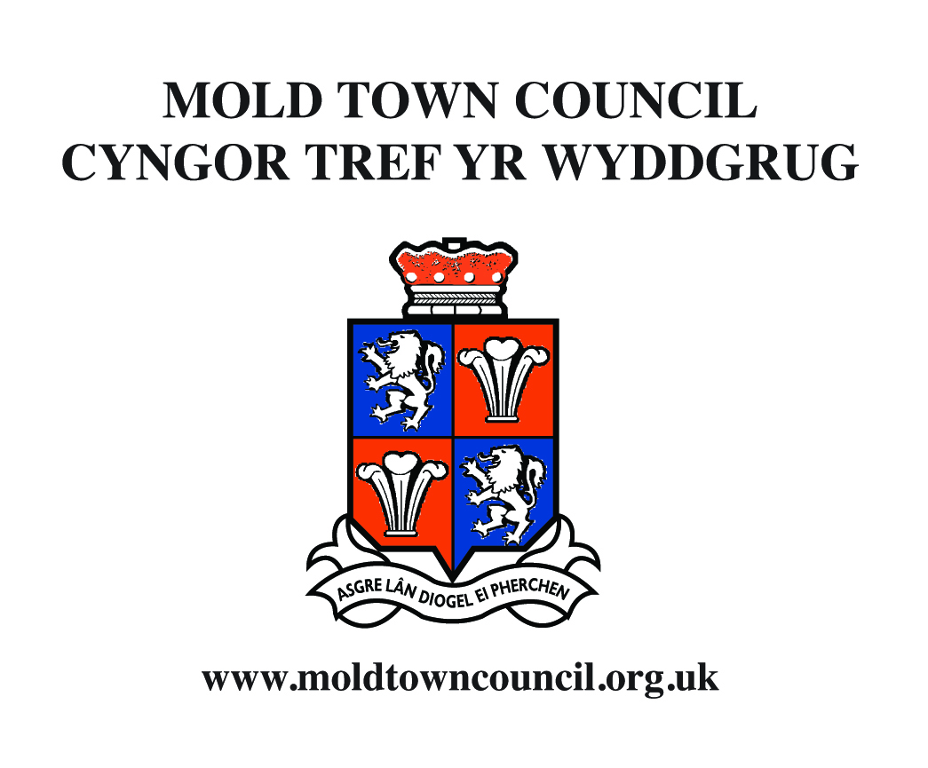
Application for Community Grant

Mold Town Council Community Grants Programme

Eligibility for a Grant;
- Your project/ event/ activity must benefit the people of Mold.
- You can be an informal group
- Demonstrate how the activity/ community group or organisation links to one or more of the 7 Well Being Goals for Wales (Well-being of Future Generations Act, 2015):
  - A prosperous Wales
  - A resilient Wales
  - A healthier Wales
  - A more equal Wales
  - A Wales of cohesive communities
  - A Wales of vibrant culture and thriving Welsh language
  - A globally responsible Wales
- Groups can only receive grant once in a financial year.
Examples of activities and items we can support:
- The capital costs, or a contribution towards the costs of, any new or replacement equipment that may be required to assist the group in its activities.
- The costs, or a contribution towards the costs involved in the presentation of an event, concert, performance or specific activity produced by a local group.
- The costs involved in the establishment of a new local voluntary or charitable group.
In addition, Mold Town Council will consider requests for grants towards the general running costs of any group. The Town Council will consider giving a commitment for a contribution for up to a period of three years towards these general running costs. These applications will only be considered at the last Financial Committee Meeting of the Financial year.

Jo Lane Uned 10, Canolfan Daniel Owen Unit 10, Daniel Owen Precint
Clerk and Finance Officer Yr Wyddgrug CH7 1AP Mold, CH7 1AP
Clerc a Swyddog Cyllid Ffôn 01352 758532 Tel. 01352 758532
Ffacs 01352 755804 Fax 01352 755804
townclerk@moldtowncouncil.org.uk townclerk@moldtowncouncil.org.uk
www.moldtowncouncil.org.uk www.moldtowncouncil.org.uk

Application for Grant

Contact Details

Applicant Name:
Organisation:
Address:
Contact number:
Email address:

Project/ Groups Details

Organisation:
Location of organisation:
Project name:
Short project description:

If you receive a grant, briefly tell us what difference if will make to your organisation/ area:
Will your project be provided/ advertised bilingually?
Please state which Well-being Goal(s) your project/ activity or event links with.

Project/ Groups Costs

Total cost of project:
Amount requested from Mold Town Council:
Amount of any confirmed matched funding (this is preferred but not essential)
Outstanding balance:
If there is a balance outstanding, please tell us how the shortfall will be met:
Please provide bank details for grant payment if successful: | Account Name:  Sort Code:  Account Number:

Project beneficiaries

Please tell us how many people you expect to benefit if you are successful with your community grant application:
Please tell us how many people you expect to benefit if you are successful with your community grant application specifically from the Town of Mold:
Where will the project/ activity take place?
How many people from Mold are members of your group:
What is the approximate age group of members?

Supporting documentation
Please complete the following table to indicate if you have the supporting documents. You do not need to send these documents in with your application (apart from your Governing Document which must be supplied with your application form) but we may request copies at a later date.

Up to date Annual accounts/ income and expenditure
Copy of your Governing Document (signed)
Planning Permission (if needed for your project)
Relevant insurances
Safeguarding Policies
Quotes/ estimates for equipment
Affiliation to a Governing Body
Equalities and Inclusion Policy

Data protection and consent
Please ensure you read this section before submitting your application.

Part or all of the information you supply will be held on out IT system. This information will be used for the administration of grant applications and for statistical analysis.
Copies of your application, but with personal details redacted, will be provided at the relevant council meetings for consideration of awarding the community grant.

For transparency purposes, information about successful grant applications is added to our website and make available to local press. The press may request contact details of someone able to provide additional information.

Please indicate below if you consent to us passing on your name and contacts to the local press for this purpose.

YES / NO

Declaration
I certify that to the best of my knowledge all the information contained within this application is current. I confirm that I understand, agree and accepts the terms and conditions of this grant as set out in Mold Town Council’s Community Grants Policy.

Signed:
Date:
Name:
Email Address:
Contact Number:
Position in group:

Please return completed application to:
Mold Town Council, Unit 10, Daniel Owen Precinct, Mold, Flintshire CH7 1AP

For further information or help completing the Community Grant Application Form, please contact:
Jo Lane, Town Clerk and Finance Officer
townclerk@moldtowncouncil.org.uk
01352 751819

