**MOLD TOWN COUNCIL**

**CYNGOR TREF YR WYDDGRUG**

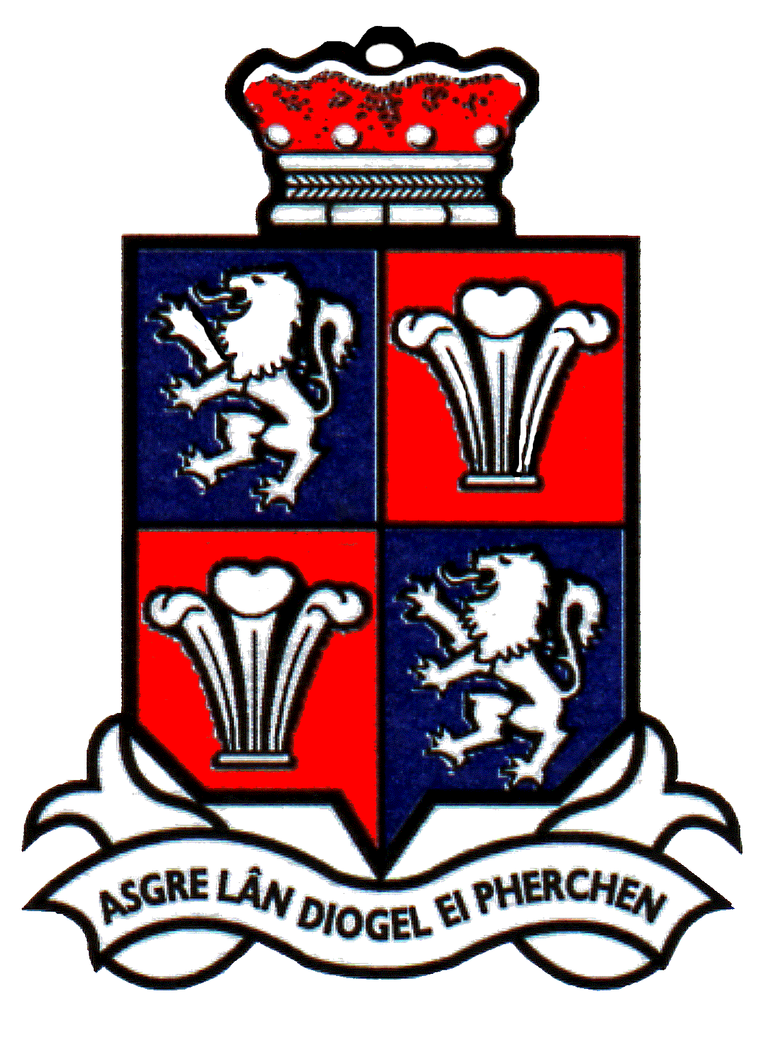

**www.moldtowncouncil.org.uk**

Town Hall

Earl Road

Mold

Flintshire

CH7 1AB

Telephone: 01352 758532

Fax: 01352 755804

Neuadd y Dref

Ffordd yr Iarll

Yr Wyddgrug

Sir y Fflint

CH7 1AB

Ffộn: 01352 758532

Ffacs: 01352 755804

**Publication of audited accounts for the year ended 31 March 2024**

Regulation 15(5) of the Accounts and Audit (Wales) Regulations 2014 (as amended) requires that by 30 September 2024, MOLD TOWN COUNCIL publishes its accounting statements for the year ended 31 March 2024, together with any certificate, opinion, or report issued, given or made by the Auditor General.

The accounting statements in the form of an annual return have been published on the Council’s website.

However, the accounts are published before the conclusion of the audit as the Auditor General has not yet issued an audit opinion.