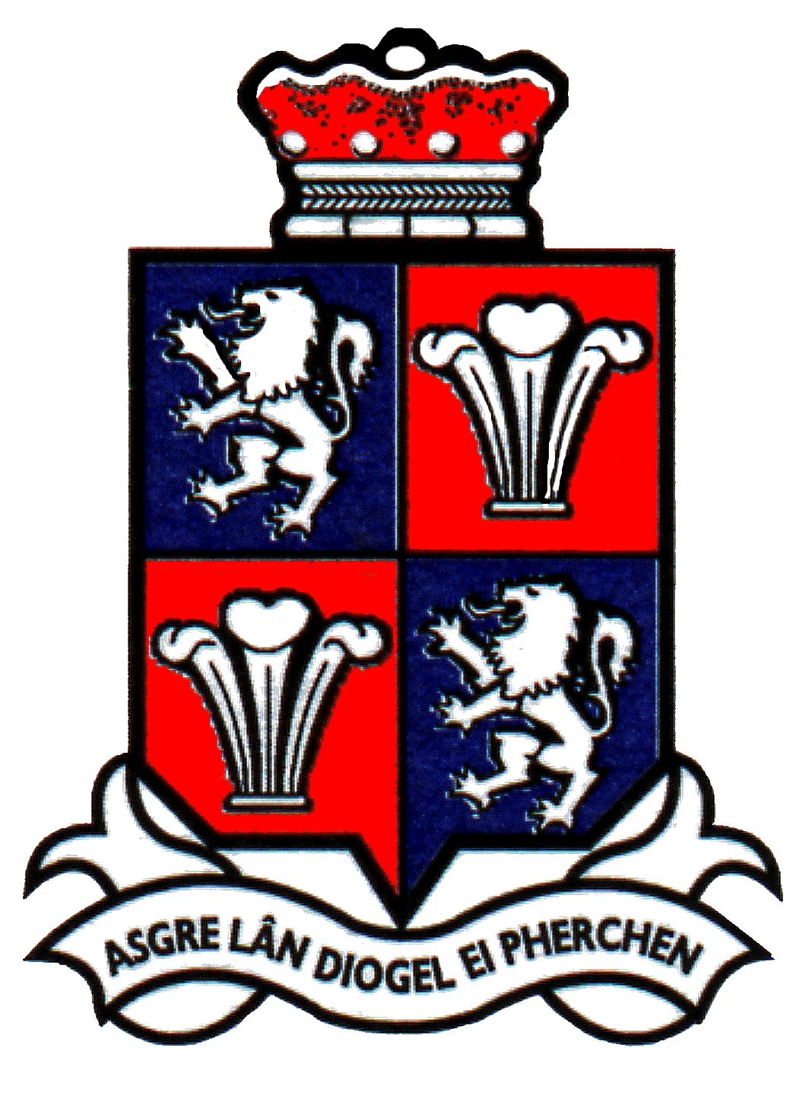

Schedule of Meetings 2025/26

The following dates are recommended for meetings of Mold Town Council during the next year (maybe subject to change):

Suggested start time: 6.00pm

28th May 2025
25th June 2025
30th July 2025
24th September 2025
29th October 2025
26th November 2025
28th January 2026
25th February 2026
26th March 2026
22nd April 2026

Annual Meeting 6th May 2026

Schedule of Committee Meetings

The following dates are suggested for meetings of Mold Town Council Committees during the next year:

Cemetery Committee

4th June 2025 - 6pm
3rd September 2025
3rd December 2025
4th March 2026

Planning Committee (Zoom)

2nd June 2025 - 6pm
30th June 2025
28th July 2025
26th August 2025 (Tues)
22nd September 2025
20th October 2025
17th November 2025
15th December 2025
12th January 2026
9th February 2026
9th March 2026
7th April 2026 (Tues)
5th May 2026 (Tues)

Community, Development & Regeneration Committee

13th May 2025, 6pm
29th July 2025, 6pm
21st October 2025, 6pm
3rd February 2026, 6pm

Personnel Committee

To be organised as and when required

Finance Committee

17th June 2025, 6pm
16th September 2025, 6pm
9th December 2025, 6pm
6th January 2026, 6pm (provisional)
17th March 2026, 6pm

Policy & Audit Committee

8th July 2025, 6pm
14th October 2025, 6pm
20th January 2026, 6pm
10th March 2026, 6pm

Youth and Children’s Council Committee

10th June 2025, 6pm
9th September 2025, 6pm
18th November 2025, 6pm
10th February 2026, 6pm
Additional meetings to be arranged as and when required.

