MOLD TOWN COUNCIL
CYNGOR TREF YR WYDDGRUG

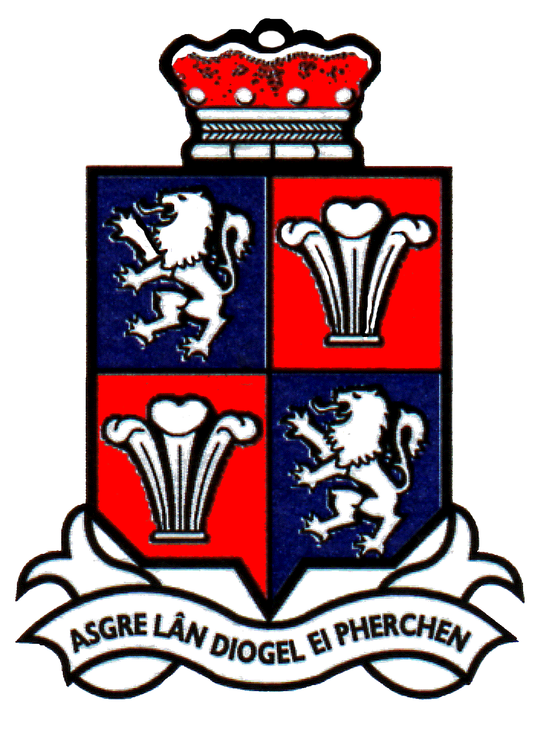
www.moldtowncouncil.org.uk
Town Hall
Earl Road
Mold
Flintshire
CH7 1AB

Telephone: 01352 758532

Neuadd y Dref
Ffordd yr Iarll
Yr Wyddgrug
Sir y Fflint
CH7 1AB

Ffộn: 01352 758532

22 June 2020

Certification and approval of annual accounts for 2019-20

Regulation 15(1) of the Accounts and Audit (Wales) Regulations 2014 (as amended) requires that Responsible Financial Officer of Mold Town Council sign and date the statement of accounts, and certify that [it properly presents Mold Town Council’s receipts and payments for the year] or [it presents fairly the financial position of Mold Town Council at the end of the year and the Council’s income and expenditure for the year]. The Regulations required that this be completed by 30 June 2020.

The Responsible Financial Officer has not signed and certified the accounts for the year ended 31 March 2020 due to delays caused by the COVID-19 outbreak. The statement of accounts will be prepared and the Responsible Financial Officer will sign and certify the statement of accounts by the end of July.

Ian Jones
Mold Town Clerk and Finance Officer

